|  |  |  |  |  |  |  |  |  |
| --- | --- | --- | --- | --- | --- | --- | --- | --- |
| **MAD Project Evaluation 1 – Regular Intake 2021** | | | | | | | | |
| **Group Name:** | Kylix Medusa | |  |  | **Batch:** | Malabe G4.2 | | |
| Student ID | Student Name | Consistency (Out of 2) | Appropriateness and Professionalism (Out of 3) | Usage of resource manager (Out of 4) | Out of box design ideas (Out of 3) | Report (Out of 8) | Total (Out of 20) | Comments |
| IT20111656 | Navoda M.R. |  |  |  |  |  |  |  |
| IT20144562 | Weerasooriya O.W.R.Y. |  |  |  |  |  |  |
| IT20034504 | Siriwardhana A.U.A |  |  |  |  |  |  |
| IT20152246 | Sonali L.D.A. |  |  |  |  |  |  |
|  |  |  |  |  |  |  |  |

Git Repository Link:

(If already created)

----------------------------------------------------------------------------------------------------------For Evaluators use only---------------------------------------------------------------------------------------------

Evaluator’s name:

Others:

TRIPOSO TOUR GUIDE MOBILE APPLICATION

1. **INTRODUCTION**

Since early days Sri Lanka is popular for attractive and best tourism places. Thus, tourists are more attractive to visit Sri Lanka. For that reason, we base our project on the Tour Guide mobile app. Personalized mobile travel guides can give individual travelers a better experience in a tourist destination by providing an individually customized experience that suits their personal preferences more than the standard guidebooks can offer.

“Triposo” app allows the tourists to choose their own tourism guidance according to their preference. They can login to the application and search for the events, hotels and restaurants and also about the travelling places according to their preference. They can also check about the top reviews of the tourist about the places and the experience they got.

The aims of this project are to provide a prototype of a mobile tourist guide, through “Triposo” app which focuses on the needs of tourists and especially tourists traveling in groups. The objectives of this project are to provide a mobile travel guide prototype that focuses on the needs of travelers.

**2. INDIVIDUAL WORK CONTRIBUTION**

|  |  |
| --- | --- |
| IT20111656 –  Login:  Login by adding username &  Password.  Sign Up:  Add customer details  User profile:  View, delete, customer services  Edit user profile:  Add, update  Make review:  Add, delete  Customer Review:  View | IT20144562 –  User: Search, select province & city  Search Event  View Event  Select Event  Admin: Search, select province and city.  Search Event  Select Event  Add Event, Add details, View event  Edit Event, Edit details  Delete Event, Delete details   * Calculate total earnings from the event and giving a 50% discounts for children age under 10. |
| IT20034504 –  User: Search travel places  Select places  View Places  Admin: Add travel places  Edit travel places  Delete Travel places  Search travel places  View travel places  Select travel places   * User view travelling location via google maps. Admin add travelling location from google maps, edit location, delete location. | IT20152246 –  User: Search city  Select city  Search Hotel  View Hotel details  Select Hotel  Admin: Search city  Select city  Search Hotel  Add Hotel, Add details  Update Hotel, Edit details  Delete Hotel, Delete details   * Calculate total payments of customers which charged for their bookings and giving discount of 10% for Sampath & BOC debit cardpayments. |

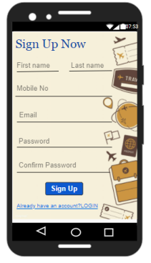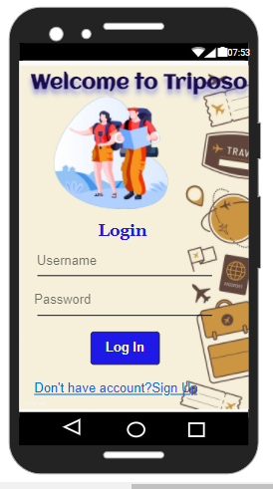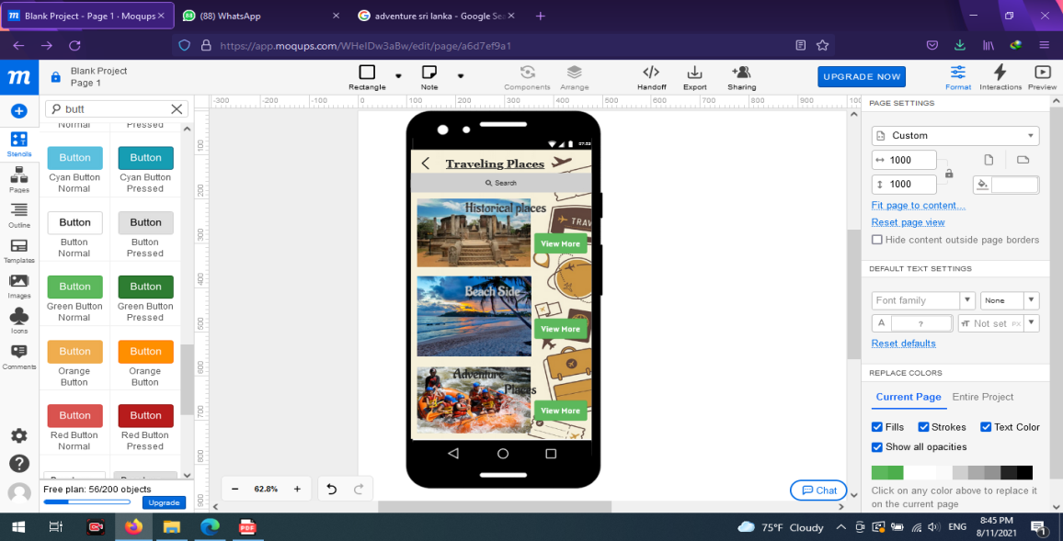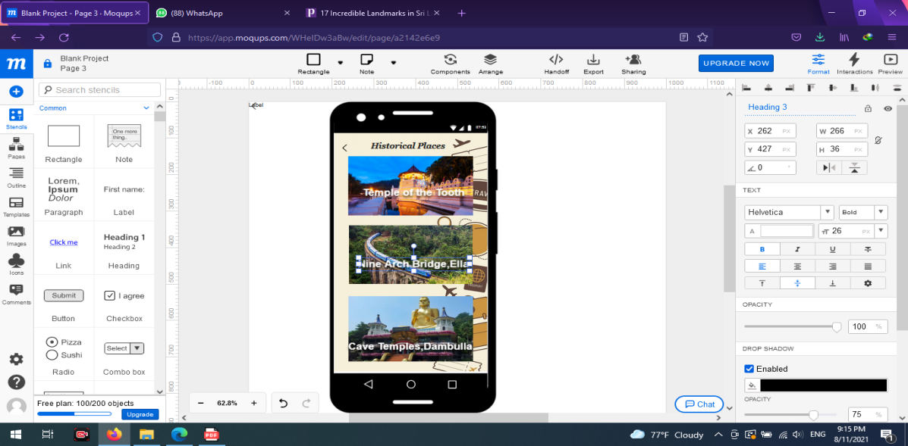 **UI CONNECTION**

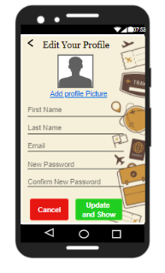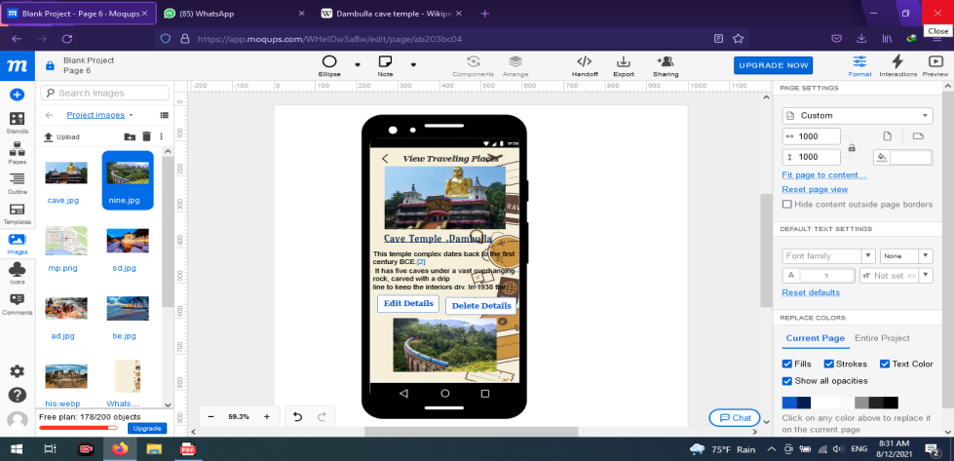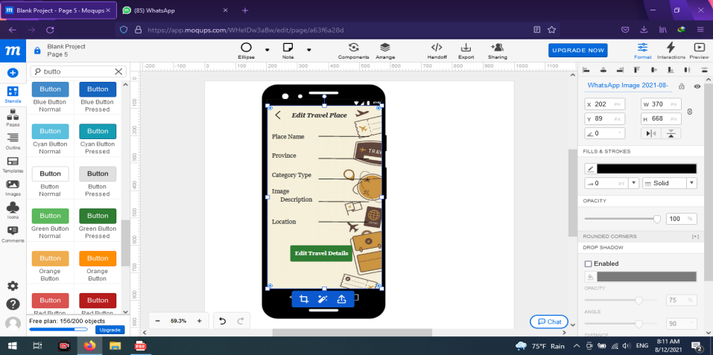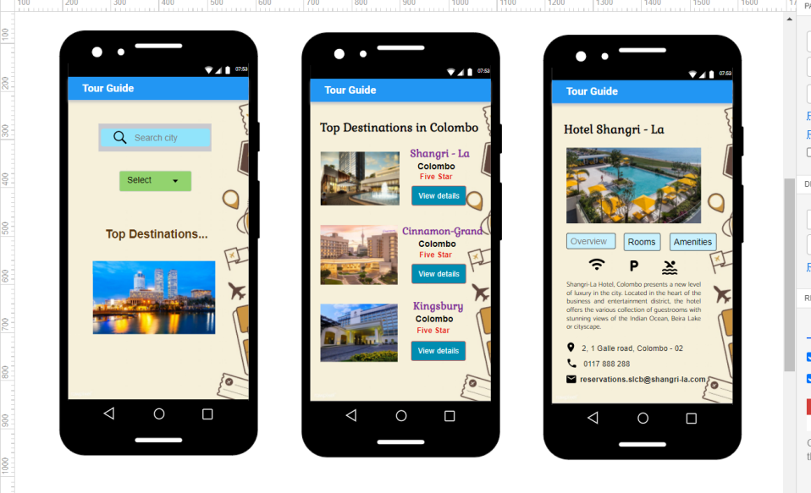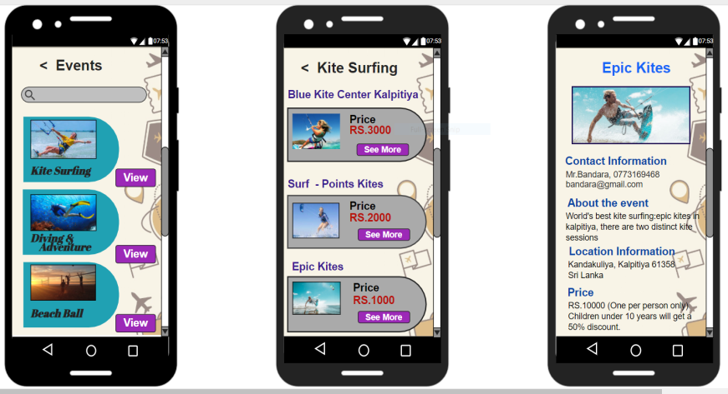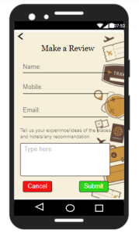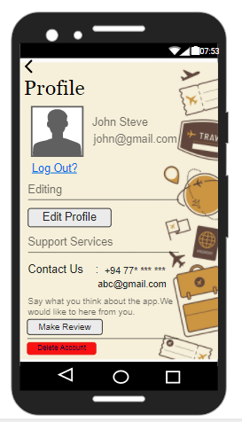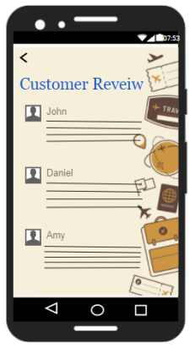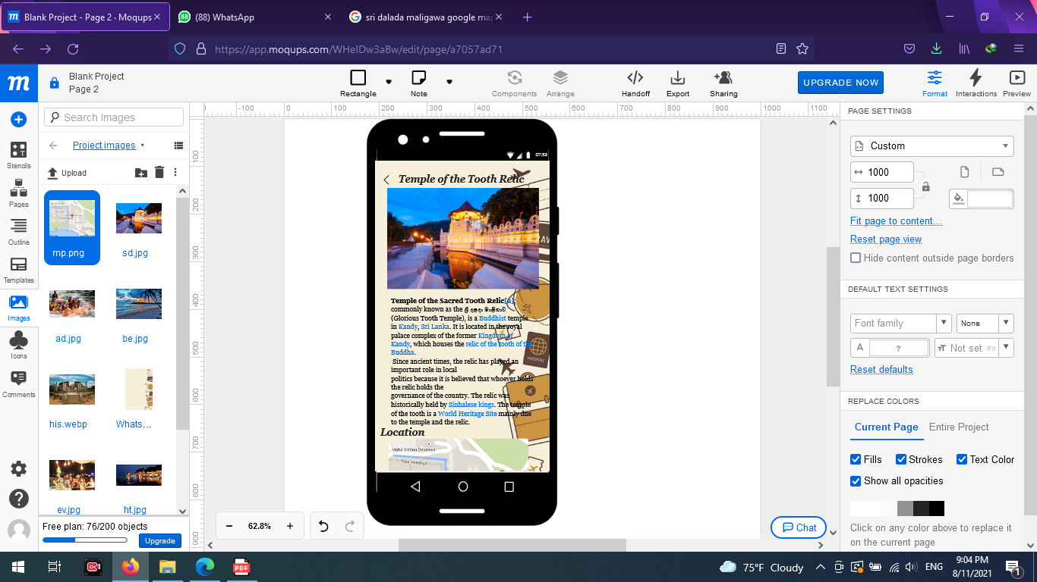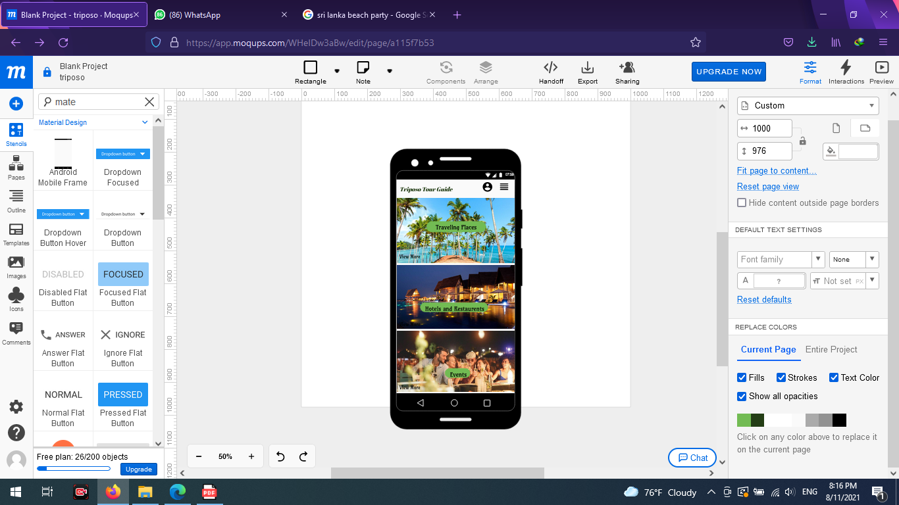

* **IT20111656 – Customer Account and Customer Review Management**

**CRUD operations and the entire functionality of the component**

* **Sign Up**

In here, the customers can register to the app by creating user account.

They can enter their details and fill the form and can create their own

User profile. Also, there is a button for registered customers to login to

their user profiles.

* **Log In**

Here the user can login to their accounts by giving username and password. Also, there is a button for customers, who are not registered to the app, by clicking that button customers can register to the app.

* **Customer’s Reviews**

By clicking the customer reviews button in the home page the users can enter to this page. In here all the users can view the reviews about hotels, travelers’ experiences and all the other reviews according to traveling, that the users have given. This page shows the most updated reviews.

* **User Review**

When the user clicks the “make review” button in the user profile page, the user redirect to this user interface. Here customers can make reviews by providing their name, mobile number, and email.

* **User Profile**

In this User interface, user can view their profile. Here user can update their profile details by clicking the ‘’edit profile’’ button which is under editing section. Also, customer can make reviews about Hotels, their traveling experiences, give ideas about to improve tourism and any kind of recommendations by clicking “make review” button. As well as users can delete their user accounts by clicking “Delete Account” button.

* **Edit Profile**

When user click the “edit profile” button, the user redirect to this user interface. Here user can update all the details according to their wish. Then they can save the update details or they can cancel the updating.

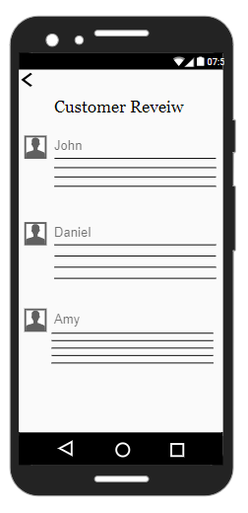

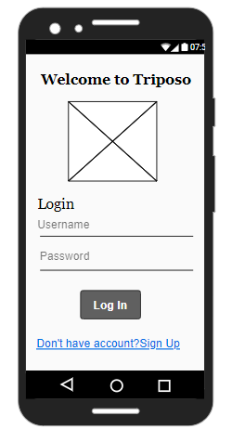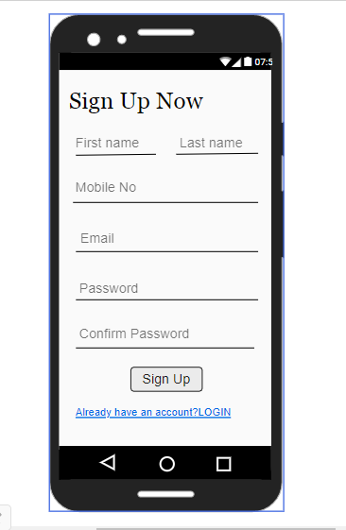

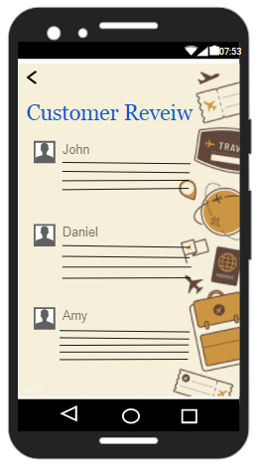

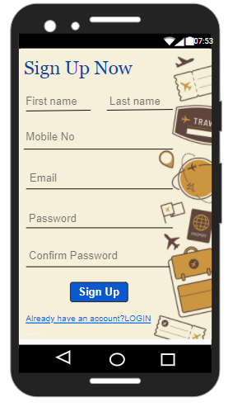

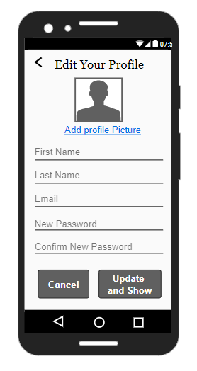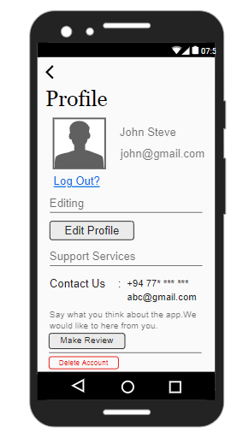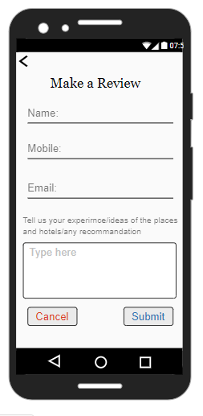

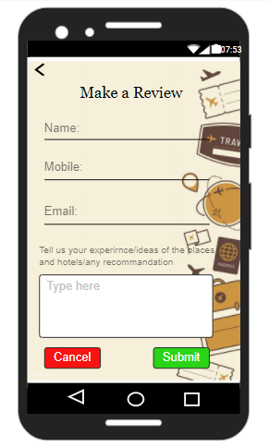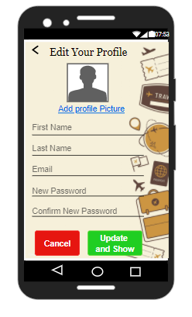

Usage of Resource Files

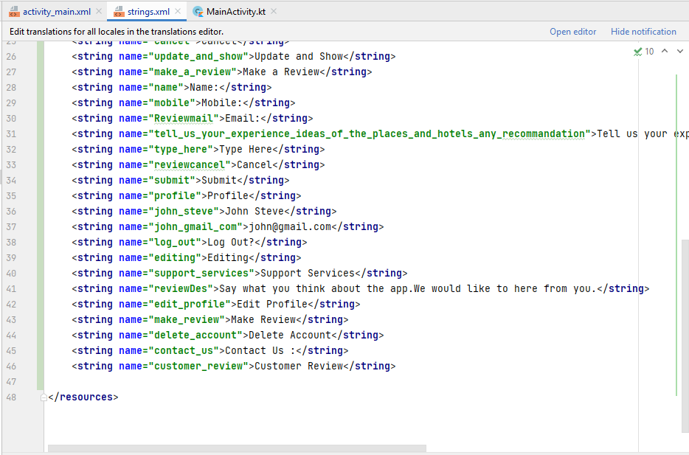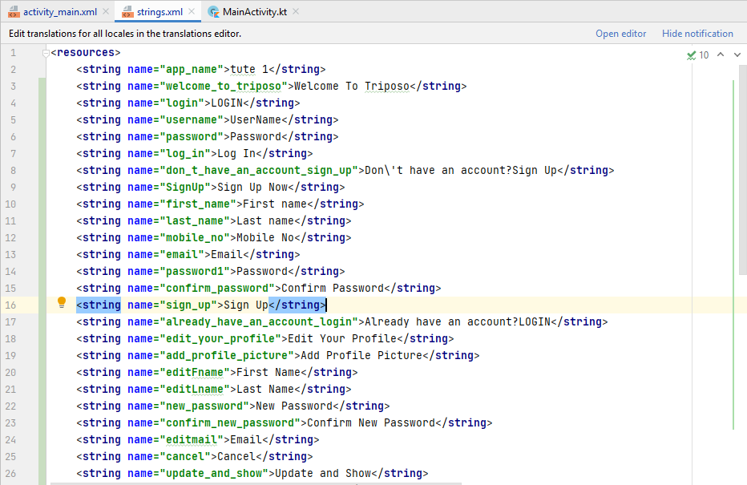

* **IT20144562 - Events management (Things that can do in each place)**

**CRUD operations and the entire functionality of the component**

In this event management section, the user and admin can search for events. And here only admin can add, edit or delete an event.

Search Event – The user/Admin can search for events by providing province or city. According to that, events will be displayed. There will be events like kite-surfing, diving, beach volleyball etc. Users can choose from a variety of events based on their preferences from the search results. After selecting one of the events, it will navigate to the places that are available. It will provide information such as price details. If the user requires additional information on the events, they can refer to this information by tapping to “see more” button. In their user can get all the details corresponding to that event.

Add Event – According to the adding events, in the admin panel admin can upload all the event details by filling the details. All the fields are must be completed. If the event added success notification appears when the admin enters new event.

Edit & Delete Events – When the admin adds all the details successfully it will navigate to the “View Event”. In their admin can change the inserted details when it is necessary. After the editing the details he should click the save changes button. And also, the admin has the ability to remove events from the application. When he wants to remove something, he has to click the delete button in the application. Then a confirmation message will appear. Once he confirms it, it will successfully delete from the application.

Finally, they calculated Total Earnings from the event. This is calculated by unit price of a ticket multiplied by number of tickets sold. And also a 50% discount on the ticket price if the ticket was bought by a person who is age under 10 years.

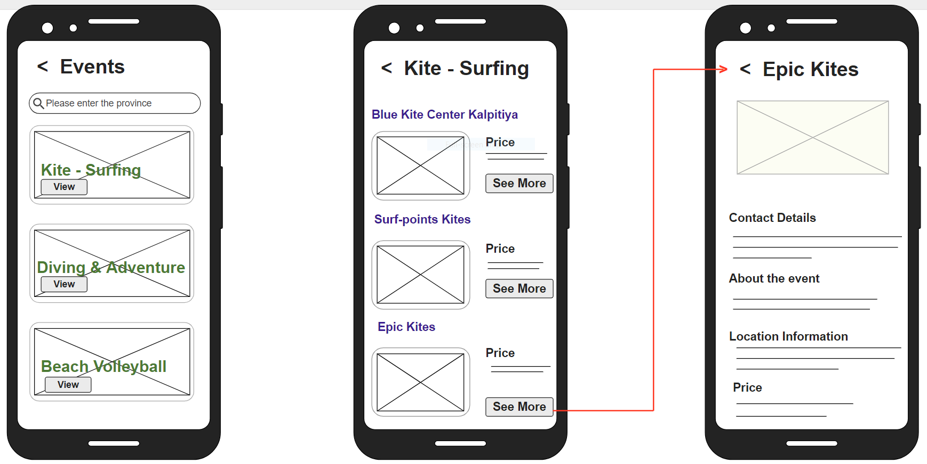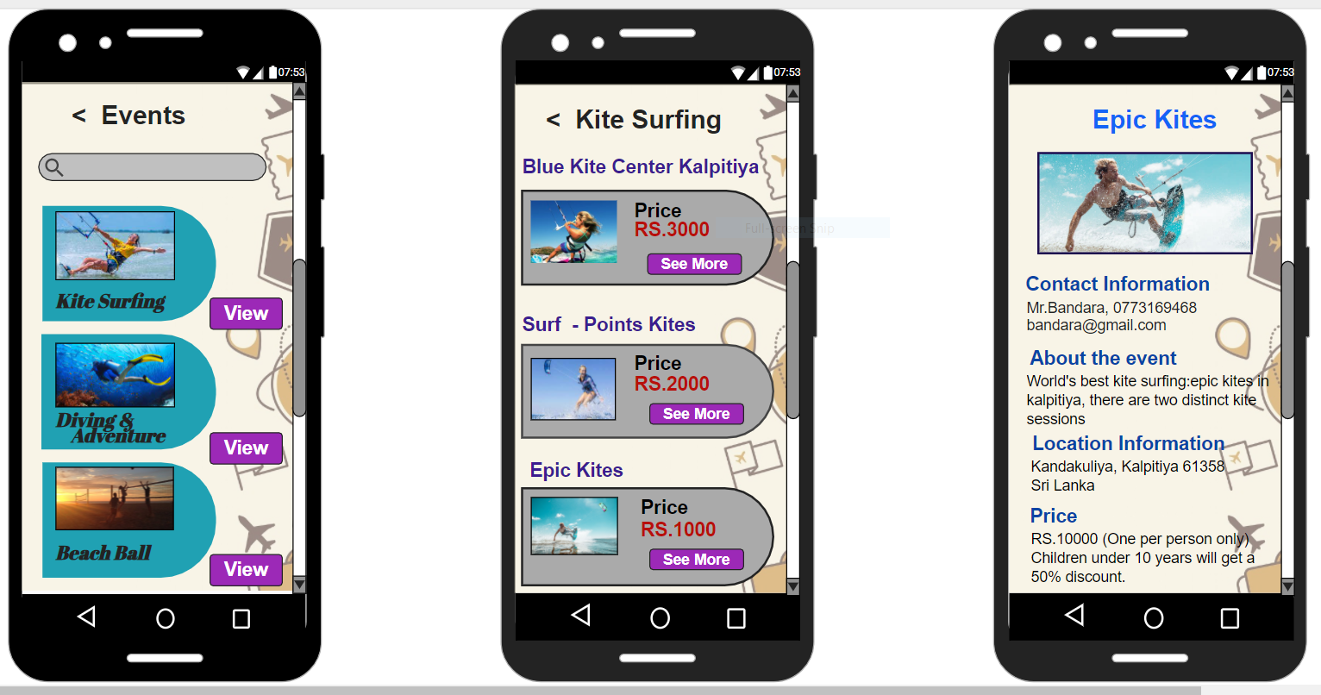

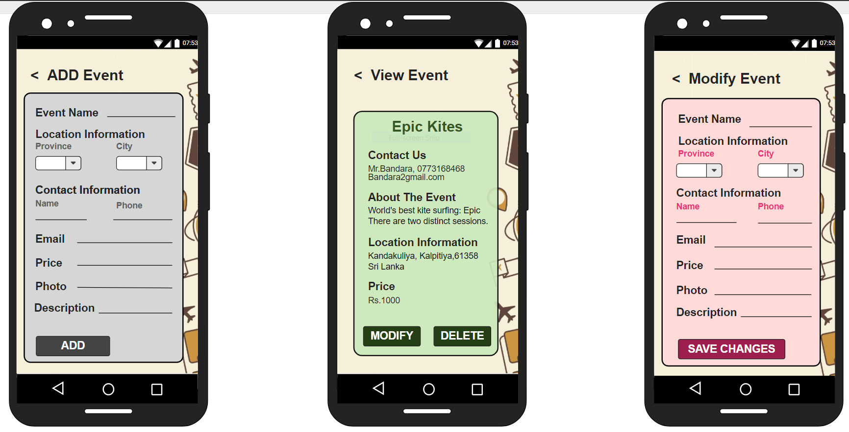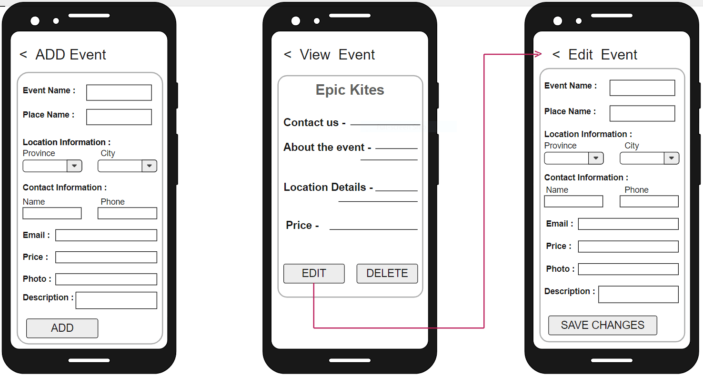

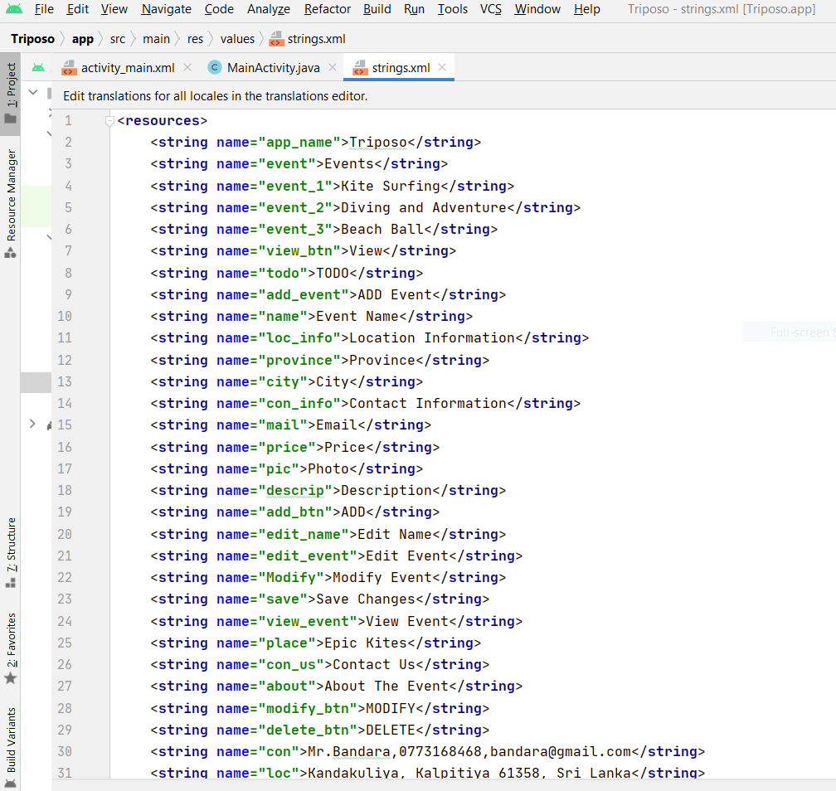 Usage of Resource Files

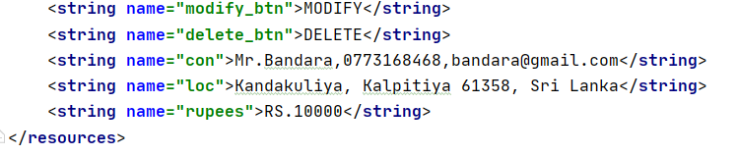

* **IT20034504 - Tourist Site Management**

**CRUD operations and the entire functionality of the component.**

In the Tourist Site Management Function Admin can do insertion, update and deletion while the referrer is only allowed to do search and view details options.

Insert- An admin can add many traveling sides island wide with different types of traveling places with a small description and the GPS locations. He can insert any type of travelling places under these three categories. Historical Places, Beach Side and Adventure places. These are the most famous topics among the travelers and mostly they are looking for. When admin insert new traveling place user gets notification about the new travel site and admin see the site added successful message.

Edit/Update-As well as Admin can edit those places for different detail updates. If some details that are displaying in the site is incorrect or need to update, then the admin have the permission to edit and save it.

Delete-And also, due to any reason, admin can delete the deserved places from the application. The admin has the ability to remove events from the application. When he wants to delete something, he can go through with the Delete button in the app. Then the system will ask for confirmation. Once he confirms, it will be thoroughly cleared from the application.

Due to this function. From the Front-end the travelers can see more details and get an idea about many travel sides places In Sri Lanka by clicking “View more” button.

Search-Users can Search Province they would like to go on a trip. When users search for a province, it will show all the traveling places that have in the selected province for each category type of traveling places. Or They can select the best traveling site form the given categories like adventure places, Historical Places, etc.

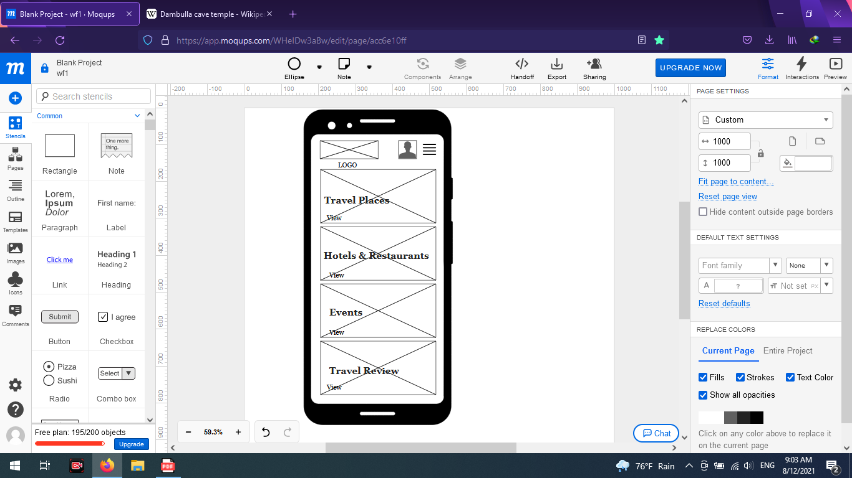 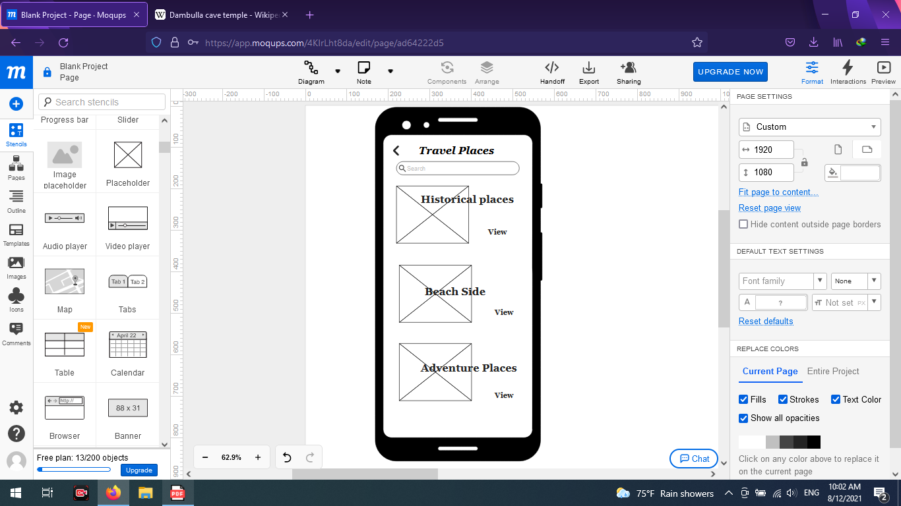 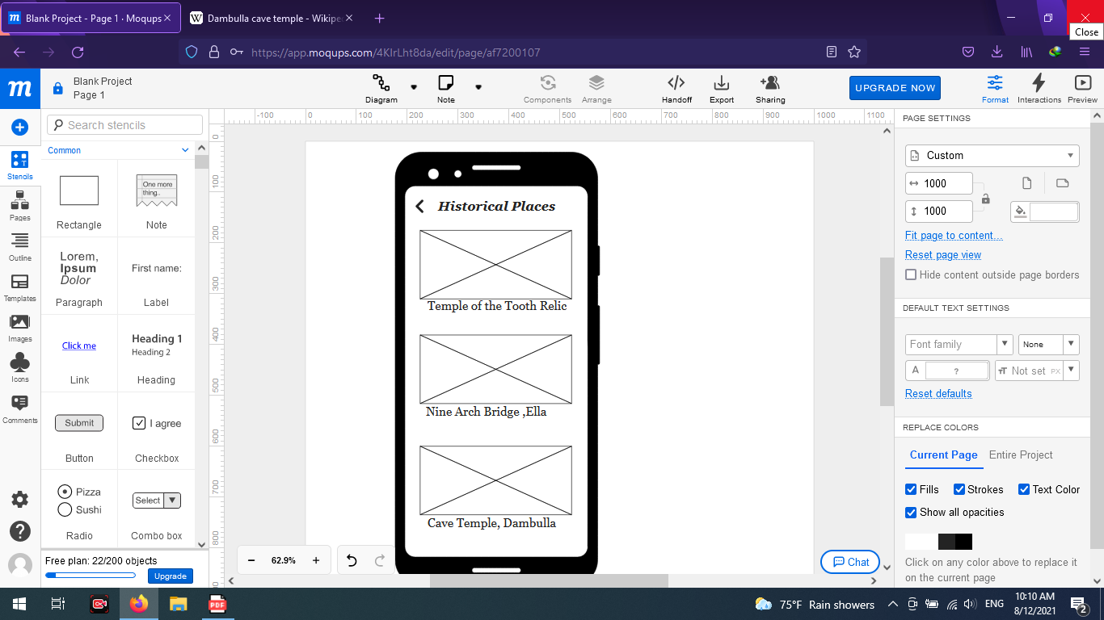 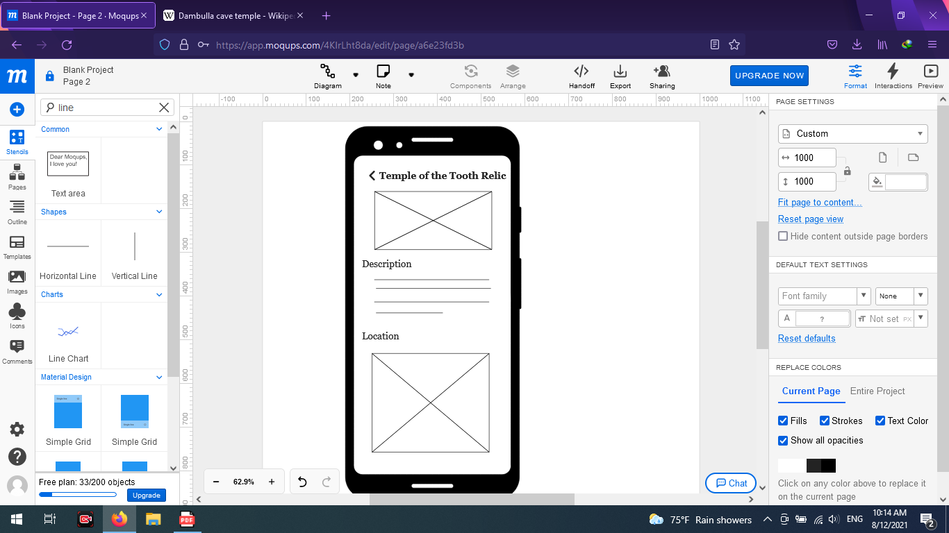

 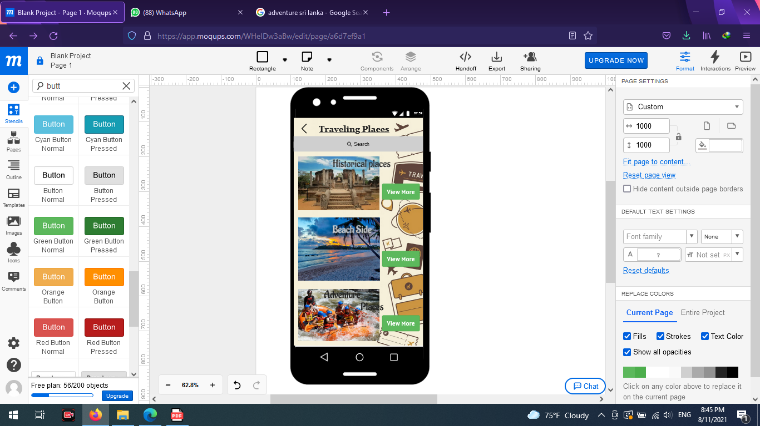 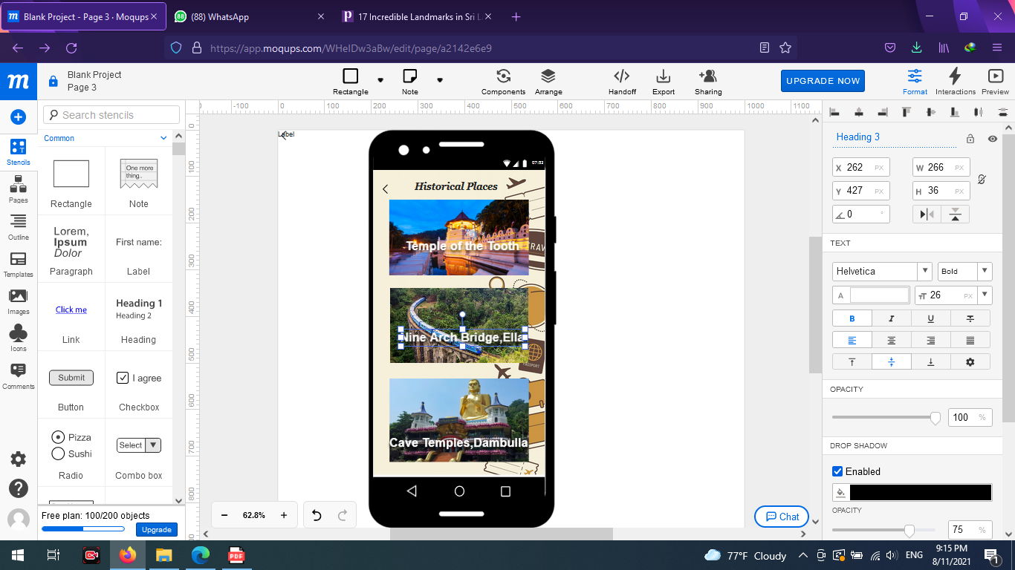 

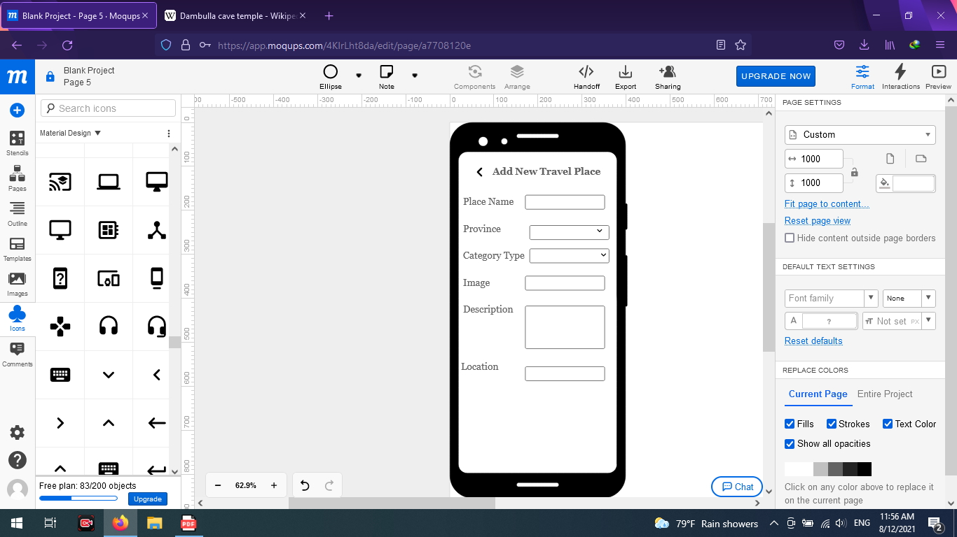 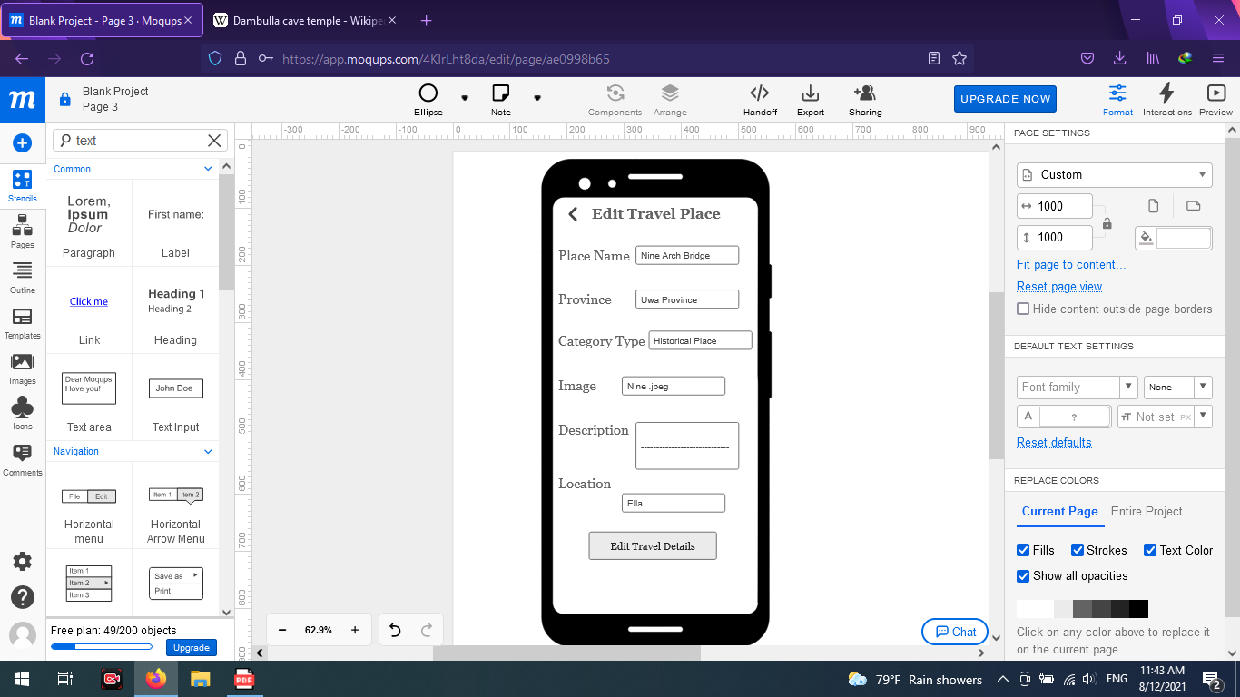 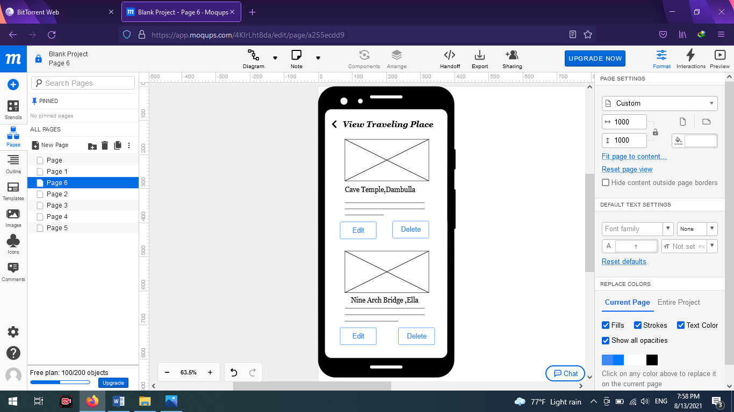

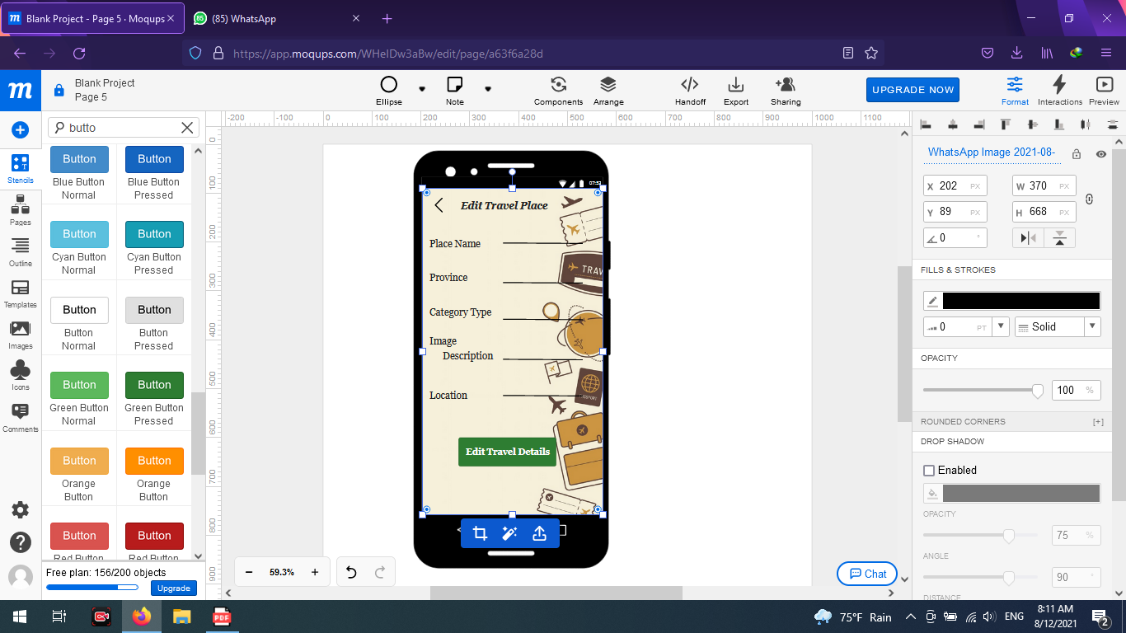 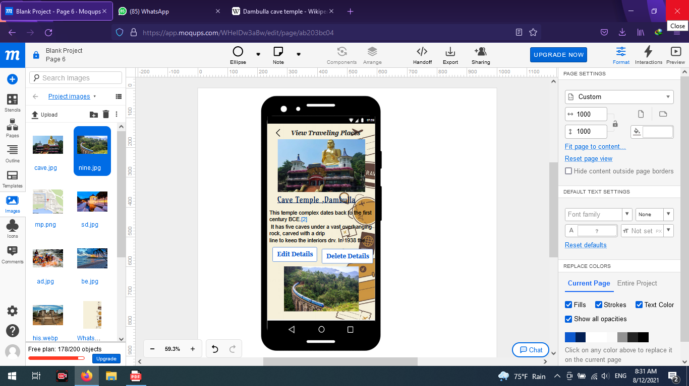 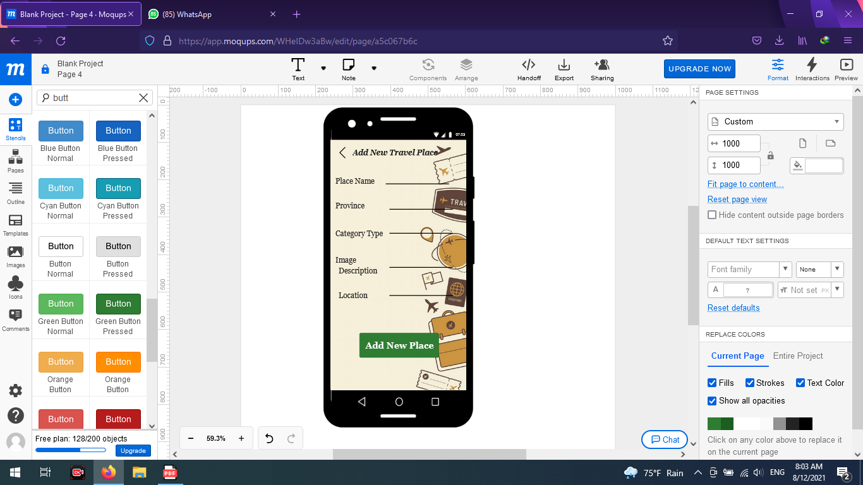

Usage of Resource Files 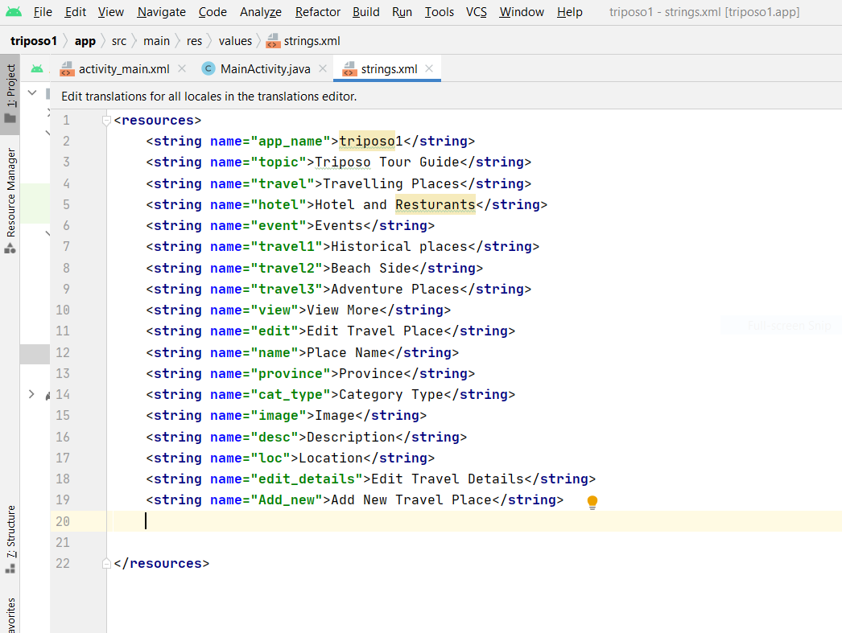

* **IT20152246 - Hotel management**

**CRUD operations and the entire functionality of the component.**

Our app is “Triposo” tour guide application. This part belongs to hotels and restaurants. In this function, both user and admin can search for hotels. And in here only admin has access to handle these three functions ADD, UPDATE and DELETE.

SEARCH Hotel - By search bar, users can search a city that they need, or in below, there is a dropdown list and by using it also you can easily search your places. After searching for your city or district all the top destinations can be seen. By search result menu, you can see the main details of each hotel and if you need more details by clicking view details you can enter that hotel page. There you can see an overview of the hotel and on that page, you can see full details of the hotel.

By changing another tab, you can choose your rooms, hotel package’s and their prices. And also, by amenities tab users can easily see the facilities of each hotel. And some hotels will display their discount packages and extra-facilities which given by them in their amenities tab. If users are interested in packages they can contact through calling or sending a mail to hotels. And these parts belong to the frontend side of the application.

ADD Hotel - By add hotels function, admin can add hotels to the app. Mainly hotel name, district, hotel type, location, prize details of hotel packages, phone, and a brief description of the hotels can be added. All the fields must be completed. When the admin adds details of a hotel and by clicking ADD button, system will display a success notification.

UPDATE Hotel details - All the details hotel name, district, hotel type, location, prize details of hotel packages, phone, and the brief description can edit from the update hotel details form. Admin can easily edit the relevant details by clicking UPDATE button.

DELETE Hotel - If admin wants to delete any hotel due to any reason admin can do easily from the delete section. By clicking DELETE button confirmation message will appear. By confirming it, admin can delete relevant details successfully.

And above all these CRUD functions are belonging to the backend of the application.

Finally, hotels can calculate the payments of the users relevant to the rooms which they booked. Rooms have different prices due to consist of extra-facilities such as A/Cs, heaters, refrigerators and bed sizes. And some hotels will give 10% discounts for SAMPATH and BOC debit card users.

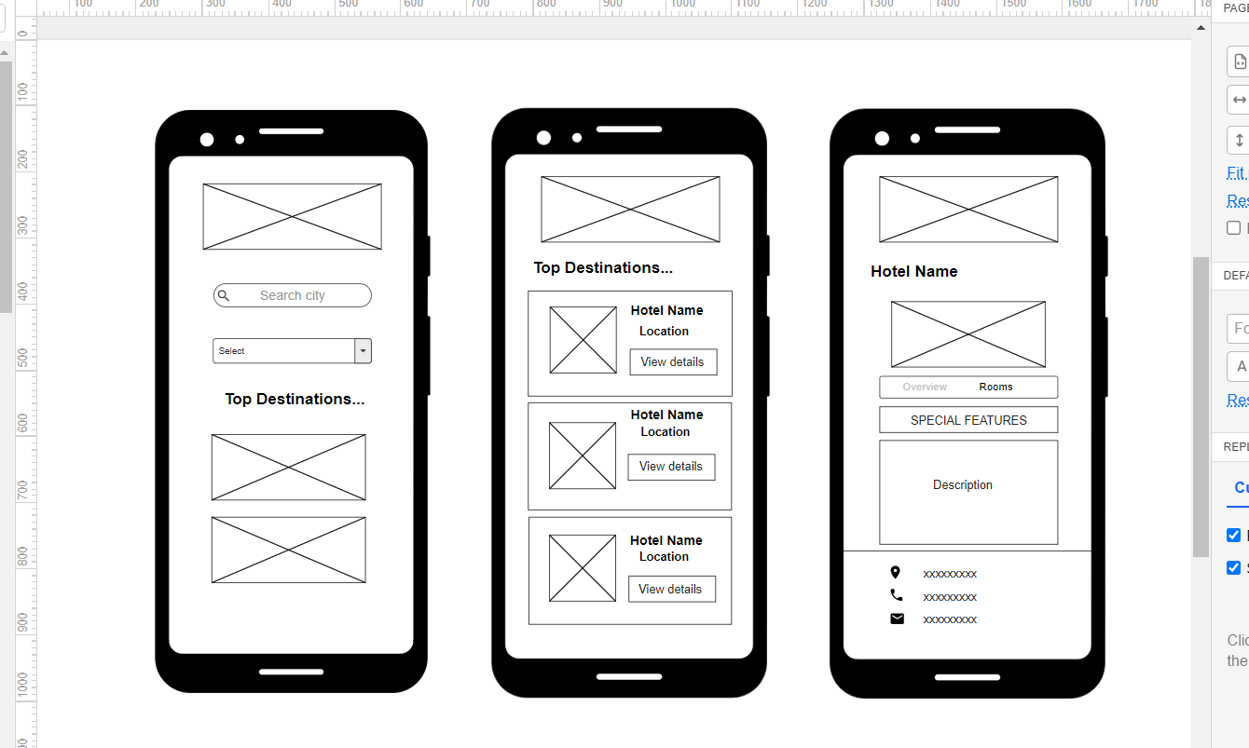

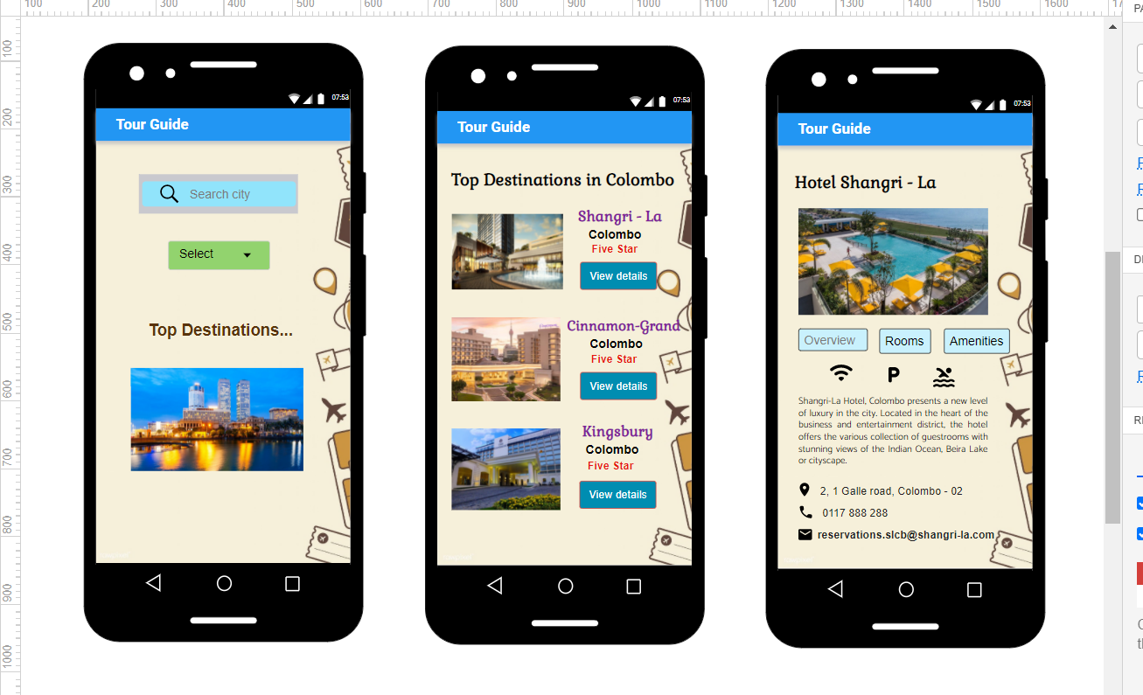

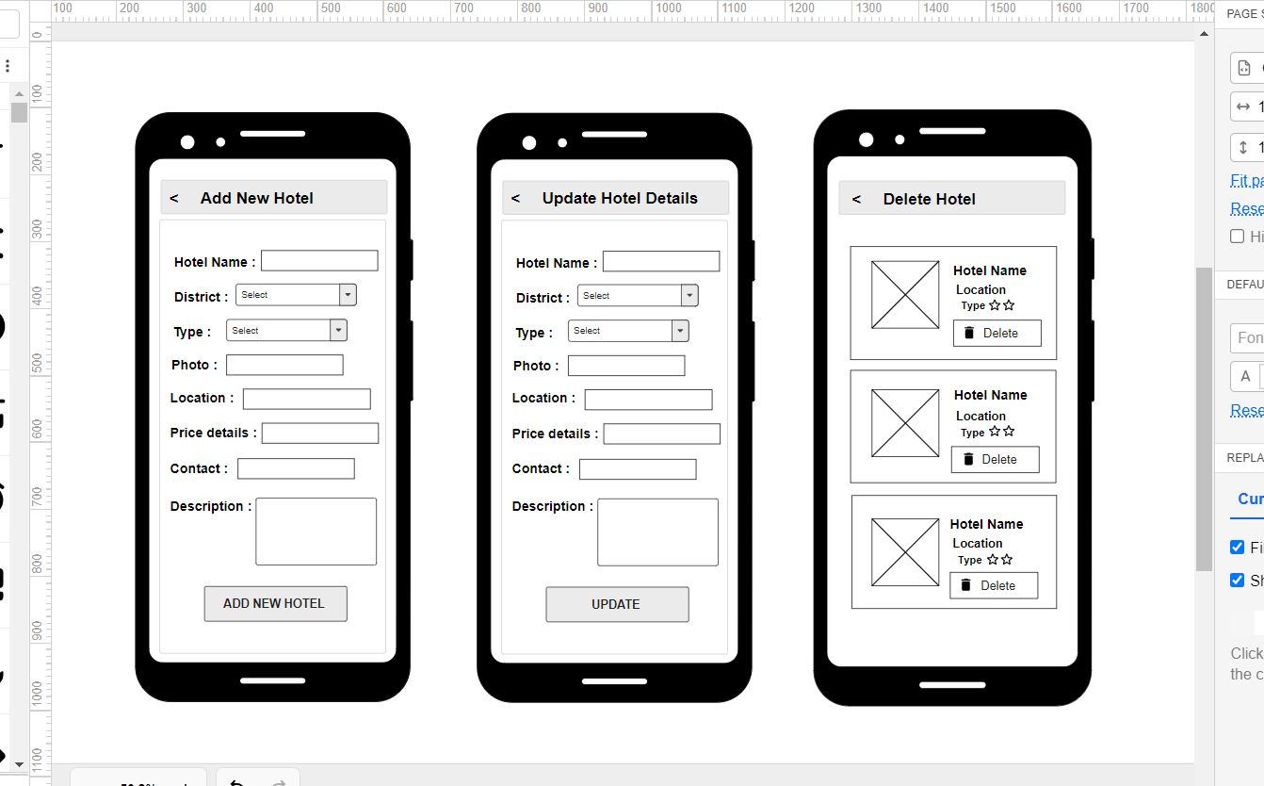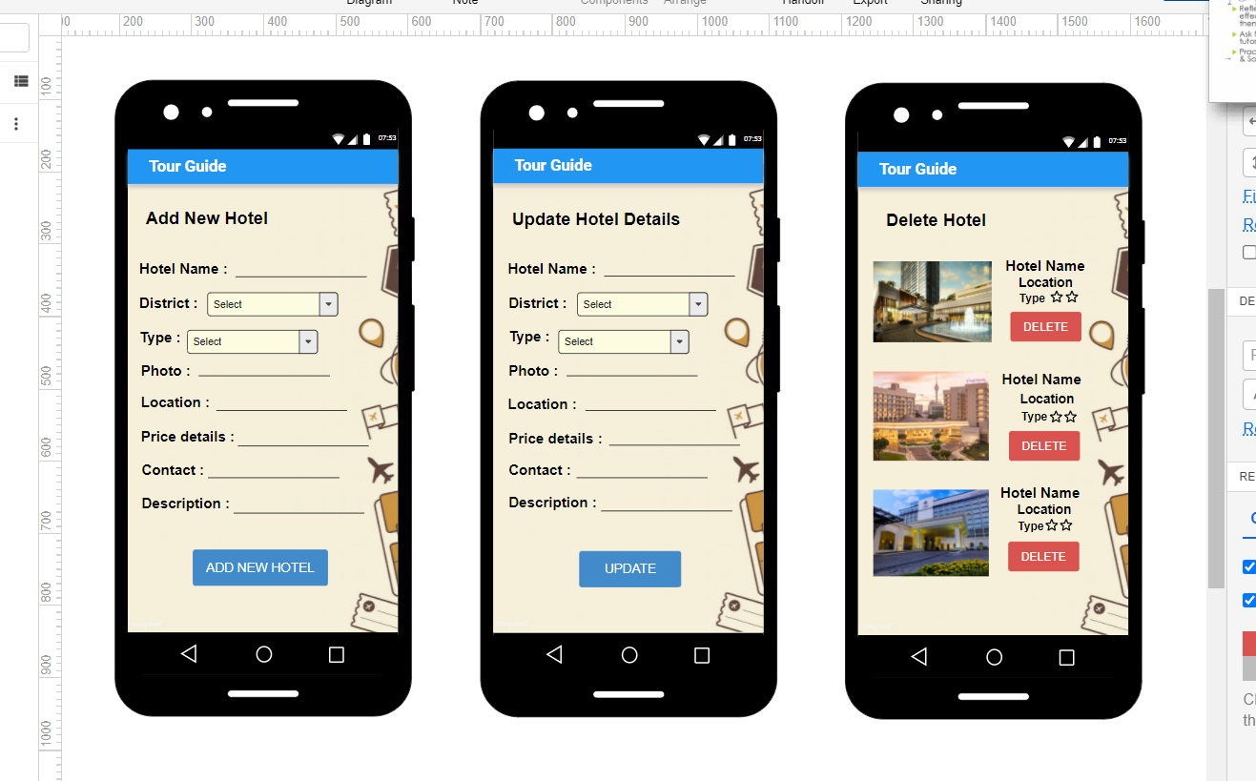

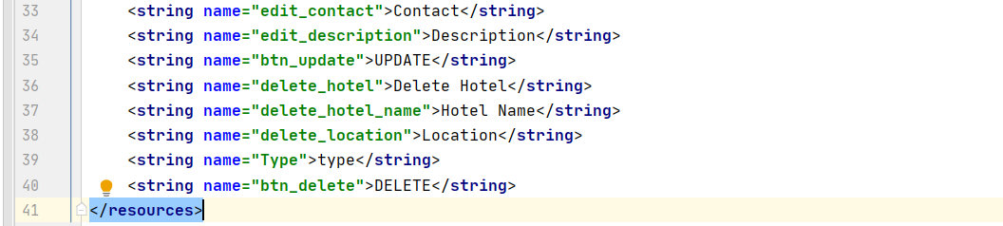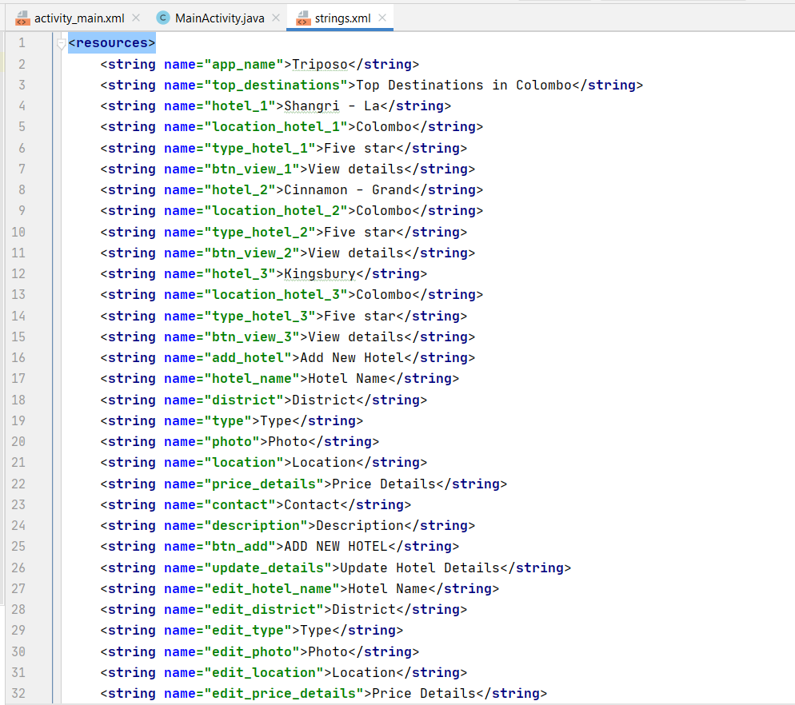Usage of Resource Files